Lab 3

The code I have try explaining the code itself via comment

I have pasted the screenshot of result

Ques1

Ques2

Ques3

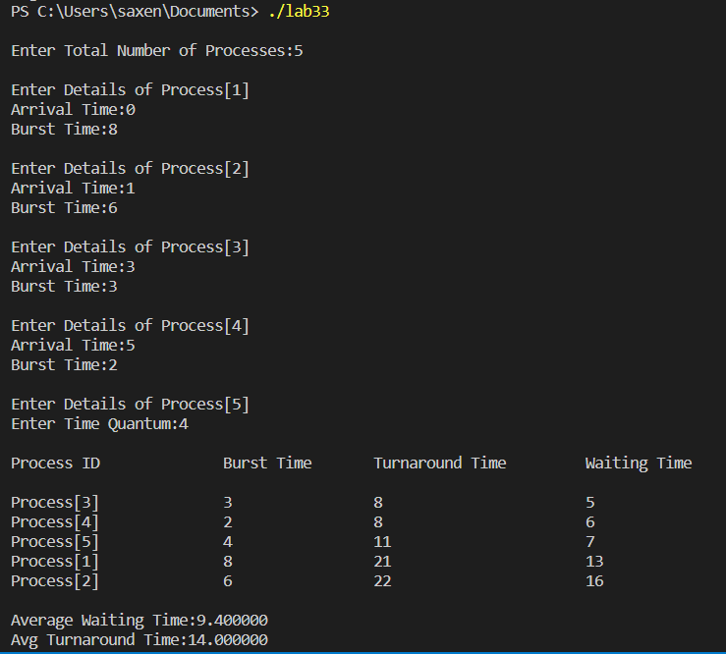

Ques4

Ques5

